**Supplementary Tables**

*Table S1. Effects of drought (D), cropping system (C), and sampling date (T) on ammonium (NH4+) and nitrate (NO3-) contents, N2O emissions, and gravimetric water content (GWC) in bulk soil assessed by three-way repeated-measures ANOVA (F=F-ratio, P=P-value, significant effects (P<0.05) are indicated in bold (ns=not significant)) (A) and the average of NH4+, NO3+, and GWC of each cropping system and irrigation treatment (SD=standard deviation) (B).*

|  |  |  |  |  |  |  |  |  |
| --- | --- | --- | --- | --- | --- | --- | --- | --- |
| 1. ANOVA | NH4+ | | NO3+ | | N2O | | GWC | |
| *F* | *P* | *F* | *P* | *F* | *P* | *F* | *P* |
| Drought (D) | 57.00 | **0.004** | 189.05 | **<0.001** | 19.99 | **0.02** | 706.77 | **<0.001** |
| Cropping System (C) | 376.27 | **<0.001** | 0.87 | ns | 3.92 | ns | 6.23 | **0.034** |
| Date (T) | 5.93 | **0.016** | 22.01 | **<0.001** | 28.07 | **<0.001** | 98.65 | **<0.001** |
| Drought x Cropping System | 38.94 | **<0.001** | 36.39 | **<0.001** | 4.48 | ns | 1.99 | ns |
| Drought x Date | 24.51 | **<0.001** | 19.17 | **<0.001** | 11.89 | **0.001** | 112.02 | **<0.001** |
| Cropping System x Date | 3.98 | **0.01** | 2.73 | **0.04** | 6.48 | **<0.001** | 0.67 | ns |
| Drought x Cropping System x Date | 5.60 | **0.001** | 1.92 | ns | 5.05 | **0.003** | 0.58 | ns |
| (B) AVERAGE | NH4+ (mg Kg-1) | | NO3+ (mg Kg-1) | | N2O (nmol m-2s-1) | | GWC (g g-1) | |
| *Mean* | *SD* | *Mean* | *SD* | *Mean* | *SD* | *Mean* | *SD* |
| BIODYN control | 0.38 | 0.52 | 14.22 | 4.33 | 0.04 | 0.04 | 0.279 | 0.05 |
| CONFYM control | 2.6 | 1.85 | 9.42 | 3.26 | 0.56 | 0.94 | 0.266 | 0.05 |
| CONMIN control | 2.14 | 1.7 | 7.79 | 3.04 | 0.66 | 1.02 | 0.257 | 0.06 |
| BIODYN drought-induced | 0.37 | 0.49 | 14.26 | 7.14 | 0.03 | 0.02 | 0.161 | 0.08 |
| CONFYM drought-induced | 11.24 | 6.97 | 26.96 | 16.93 | 0.06 | 0.04 | 0.133 | 0.08 |
| COMIN drought-induced | 11.29 | 8.27 | 29.17 | 20.19 | 0.05 | 0.11 | 0.141 | 0.08 |

*Table S2. Effects of drought (D), cropping system (C), and sampling date (T) on the alpha diversity (observed richness and Shannon Index) in bulk soil (BS) and rhizosphere (RS) assessed by three-way repeated-measures ANOVA (F=F-ratio, P=P-value). Significant effects (P<0.05) are indicated in bold (ns=not significant).*

|  |  |  |  |  |  |  |  |  |  |  |  |  |
| --- | --- | --- | --- | --- | --- | --- | --- | --- | --- | --- | --- | --- |
| Richness | AOB | | | | AOA | | | | Comammox | | | |
| BS | | RS | | BS | | RS | | BS | | RS | |
| *F* | *P* | *F* | *P* | *F* | *P* | *F* | *P* | *F* | *P* | *F* | *P* |
| Drought (D) | 4.75 | ns | 0.18 | ns | 0.06 | ns | 0.99 | ns | 0.20 | ns | 2.03 | ns |
| Cropping System (C) | 24 | **0.006** | 21.64 | **0.002** | 1.51 | ns | 3.99 | ns | 7.81 | **0.04** | 7.99 | **0.02** |
| Date (T) | 1.57 | ns | 1.90 | ns | 1.71 | ns | 1.14 | ns | 1.41 | ns | 6.37 | **0.03** |
| Drought x Cropping System | 0.36 | ns | 0.40 | ns | 0.37 | ns | 0.22 | ns | 9.55 | **0.03** | 0.95 | ns |
| Drought x Date | 1.37 | ns | 1.82 | ns | 0.38 | ns | 0.15 | ns | 1.43 | ns | 0.27 | ns |
| Cropping System x Date | 1.81 | ns | 0.16 | ns | 0.50 | ns | 0.47 | ns | 0.99 | ns | 1.24 | ns |
| Drought x Cropping System x Date | 0.24 | ns | 0.21 | ns | 0.63 | ns | 0.20 | ns | 1.25 | ns | 0.56 | ns |
| Shannon | AOB | | | | AOA | | | | Comammox | | | |
| BS | | RS | | BS | | RS | | BS | | RS | |
| *F* | *P* | *F* | *P* | *F* | *P* | *F* | *P* | *F* | *P* | *F* | *P* |
| Drought (D) | 14.3 | ns | 0.14 | ns | 0.225 | ns | 0.73 | ns | 7E-05 | ns | 0.7 | ns |
| Cropping System (C) | 28.3 | **0.004** | 25.24 | **0.01** | 4.696 | 0.05 | 5.40 | **0.04** | 7.963 | **0.04** | 7.44 | **0.02** |
| Date (T) | 0.9 | ns | 1.18 | ns | 1.562 | ns | 4.15 | ns | 2.761 | ns | 11.2 | **0.009** |
| Drought x Cropping System | 0.2 | ns | 0.91 | ns | 0.201 | ns | 0.16 | ns | 9.501 | **0.03** | 0.47 | ns |
| Drought x Date | 0.97 | ns | 0.91 | ns | 0.848 | ns | 0.41 | ns | 3.056 | ns | 0.49 | ns |
| Cropping System x Date | 1.53 | ns | 0.40 | ns | 0.871 | ns | 0.16 | ns | 2.46 | ns | 0.34 | ns |
| Drought x Cropping System x Date | 0.45 | ns | 0.37 | ns | 1.316 | ns | 0.59 | ns | 0.52 | ns | 0.48 | ns |

*Table S3. Effects of drought (D), cropping system (C), and sampling date (T) on the ammonia-oxidizers abundance in bulk soil (BS) and rhizosphere (RS) assessed by three-way repeated-measures ANOVA (F=F-ratio, P=P-value). Significant effects (P<0.05) are indicated in bold (ns=not significant).*

|  |  |  |  |  |  |  |  |  |  |  |  |  |  |  |  |  |
| --- | --- | --- | --- | --- | --- | --- | --- | --- | --- | --- | --- | --- | --- | --- | --- | --- |
|  | AOB | | | | AOA | | | | COMA-A | | | | COMA-B | | | |
| BS | | RS | | BS | | RS | | BS | | RS | | BS | | RS | |
| *F* | *P* | *F* | *P* | *F* | *P* | *F* | *P* | *F* | *P* | *F* | *P* | *F* | *P* | *F* | *P* |
| Drought (D) | 15.8 | **0.028** | 8.50 | ns | 0.44 | ns | 12.54 | **0.03** | 3.55 | ns | 0.18 | ns | 23.62 | **0.017** | 1.87 | ns |
| Cropping System (C) | 1.42 | ns | 7.16 | **0.02** | 8.05 | **0.02** | 1.39 | ns | 7.81 | **0.021** | 1.50 | ns | 11.17 | **0.009** | 17.18 | **0.003** |
| Date (T) | 13.3 | **0.001** | 1.81 | ns | 8.05 | **0.006** | 4.37 | ns | 12.4 | **0.001** | 10.93 | **0.01** | 13.90 | **0.001** | 2.04 | ns |
| Drought x Cropping System | 23.3 | **0.001** | 0.35 | ns | 0.61 | ns | 0.25 | ns | 1.02 | ns | 0.13 | ns | 0.82 | ns | 0.48 | ns |
| Drought x Date | 0.1 | ns | 1.65 | ns | 4.02 | **0.04** | 1.19 | ns | 5.69 | **0.018** | 0.95 | ns | 2.39 | ns | 0.57 | ns |
| Cropping System x Date | 0.31 | ns | 0.72 | ns | 0.63 | ns | 1.43 | ns | 0.74 | ns | 1.10 | ns | 2.21 | ns | 1.57 | ns |
| Drought x Cropping System x Date | 1.07 | ns | 1.36 | ns | 0.88 | ns | 1.33 | ns | 0.65 | ns | 6.55 | **0.005** | 3.44 | **0.019** | 0.93 | ns |

*Table S4. Effects of drought (D), cropping system (C), and sampling date (T) on the 16S rRNA gene abundance and the ratio of ammonia-oxidizers within total community in bulk soil (BS) and rhizosphere (RS) assessed by linear mixed model and three-way repeated-measures ANOVA, respectively (F=F-ratio, P=P-value). Significant effects (P<0.05) are indicated in bold (ns=not significant).*

|  |  |  |  |  |  |  |  |  |  |  |  |  |  |  |  |  |
| --- | --- | --- | --- | --- | --- | --- | --- | --- | --- | --- | --- | --- | --- | --- | --- | --- |
|  | 16S rRNA | | | | AOB/16S | | | | COMA-A/16S | | | | COMA-B/16S | | | |
|  | BS | | RS | | BS | | RS | | BS | | RS | | BS | | RS | |
|  | F | P | F | P | F | P | F | P | F | P | F | P | F | P | F | P |
| Drought (D) | 0.06 | ns | 3.182 | ns | 8.43 | **0.006** | 2.338 | ns | 4.69 | **0.03** | 0.213 | ns | 38.96 | **<0.001** | 0.404 | ns |
| Cropping System (C) | 2.71 | ns | 1.419 | ns | 5.32 | **0.02** | 4.784 | ns | 0.25 | ns | 1.989 | ns | 4.70 | **0.04** | 7.087 | **0.02** |
| Date (T) | 61.09 | **<0.001** | 0.591 | ns | 1.85 | ns | 1.651 | ns | 7.81 | **<0.001** | 1.752 | ns | 4.53 | **0.01** | 1.748 | ns |
| Drought x Cropping System | 8.47 | **0.001** | 0.637 | ns | 0.21 | ns | 0.568 | ns | 2.24 | ns | 3.628 | ns | 7.75 | **0.001** | 4.801 | ns |
| Drought x Date | 1.40 | ns | 0.663 | ns | 0.84 | ns | 2.766 | ns | 0.79 | ns | 0.211 | ns | 1.03 | ns | 0.85 | ns |
| Cropping System x Date | 0.35 | ns | 0.365 | ns | 0.24 | ns | 0.16 | ns | 0.57 | ns | 0.302 | ns | 1.22 | ns | 2.568 | ns |
| Drought x Cropping System x Date | 4.76 | **0.001** | 1.266 | ns | 1.68 | ns | 3.33 | **0.04** | 1.54 | ns | 1.034 | ns | 4.26 | **0.002** | 0.382 | ns |

*Table S5. Effects of drought (D), cropping system (C), and sampling date (T) on the AOA/AOB ratio abundance in bulk soil (BS) and rhizosphere (RS) assessed by three-way repeated-measures ANOVA, respectively (F=F-ratio, P=P-value). Significant effects (P<0.05) are indicated in bold (ns=not significant).*

|  |  |  |  |  |
| --- | --- | --- | --- | --- |
|  | AOA/AOB | | | |
| BS | | RS | |
| F | P | F | P |
| Drought (D) | 3.91 | ns | 4.39 | ns |
| Cropping System (C) | 57.35 | **<0.001** | 6.32 | **0.03** |
| Date (T) | 9.59 | **0.003** | 1.01 | ns |
| Drought x Cropping System | 1.18 | ns | 0.65 | ns |
| Drought x Date | 2.62 | ns | 6.09 | **0.03** |
| Cropping System x Date | 0.98 | ns | 0.83 | ns |
| Drought x Cropping System x Date | 0.46 | ns | 1.94 | ns |

**Supplementary Figures**

*Fig. S1. Gravimetric water content (GWC) of control and drought-treated plots. The effect of drought (D), cropping system (C), and sampling date (T), as well as their interactions was assessed by three-way repeated measures ANOVA. Pairwise comparison between control and drought for each sampling date within cropping system was assessed using the estimated marginal means with significant differences indicated by asterisks (****P<0.0001, ***P<0.001, **P<0.01, *P<0.05, ns=not significant). ﻿Boxplots show the median (center line), first and third quartiles (box limits), and smallest and largest values within 1.5x interquartile range (whiskers).*

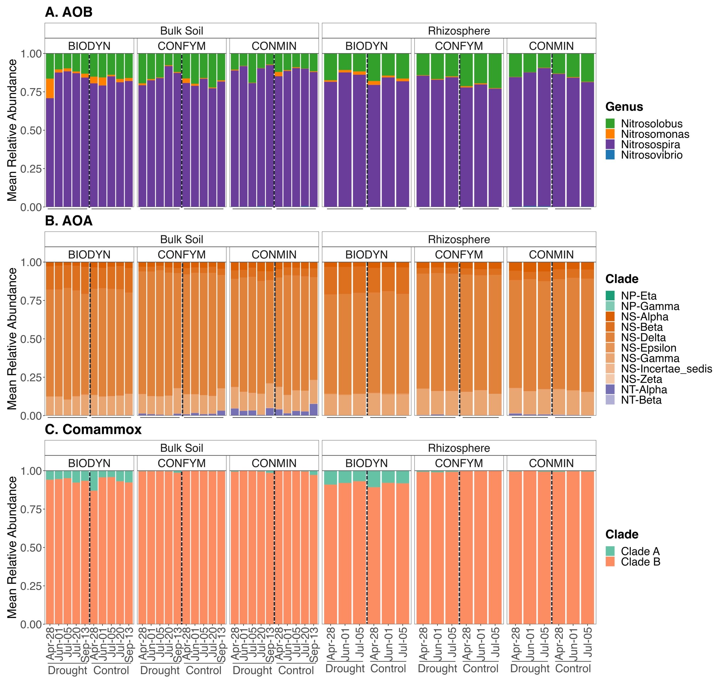

Fig. S2. Community composition of AOB (A), (AOA) (B), and comammox (C) at genus and clade level in bulk soil and rhizosphere. Bar represents mean relative abundance for each cropping system and irrigation treatment per sampling date (n=4).

*Fig. S3. Community alpha diversity in bulk soil and rhizosphere according to observed richness and Shannon diversity index of AOB (A,D,G,J) , AOA (B,E,H,K), and comammox (C,F,I,L). The effect of drought (I), cropping system (C), and sampling date (D), as well as their interactions was assessed by three-way repeated measures ANOVA with significant differences indicated by asterisks (***P<0.001, **P<0.01, *P<0.05). Pairwise comparison between control and drought for each sampling date within cropping system was assessed using the estimated marginal means (non-significant differences (ns) are not shown). Boxplots show the median (center line), first and third quartiles (box limits), and smallest and largest values within 1.5x interquartile range (whiskers).*



*Fig. S4. Principal coordinates analysis (PCoA) plot of the Bray-Curtis distance matrices of AOB (A, B), AOA (C, D), and comammox (E, F) in bulk soil and rhizosphere clustered by cropping system and irrigation treatment.*

*Fig. S5. Euclidean distance between control and drought treatment for each cropping system calculated from the position of the sites provided by the discriminant analysis (CAP). The significant difference among cropping systems was assessed by Kruskal-Wallis (P<0.05). ﻿The letters indicate significantly different statistical groups (Dunn’s test, P<0.05). Different Boxplots show the median (center line), first and third quartiles (box limits), and smallest and largest values within 1.5x interquartile range (whiskers).*

*Fig. S6. The ratio of amoA gene abundance of AOB (A, B), comammox clade A (C, D) and clade B (E, F) within total community (16S rRNA gene) in bulk soil and rhizosphere. The effect of drought (I), cropping system (C), and sampling date (D), as well as their interactions on the amoA/16S rRNA gene ratio was assessed by linear mixed model (bulk soil) and three-way repeated measures ANOVA (rhizosphere). Pairwise comparison between control and drought for each sampling date within cropping system was assessed using the estimated marginal means with significant differences indicated by asterisks (****P<0.0001, ***P<0.001, **P<0.01, *P<0.05, ns=not significant). Boxplots show the median (center line), first and third quartiles (box limits), and smallest and largest values within 1.5x interquartile range (whiskers).*

*Fig. S7. The ratio of amoA gene abundance of AOA to AOB in bulk soil (A) and rhizosphere (B). The effect of drought (I), cropping system (C), and sampling date (D), as well as their interactions on the amoA/16S rRNA gene ratio was assessed by three-way repeated measures ANOVA. Pairwise comparison between control and drought for each sampling date within cropping system was assessed using the estimated marginal means with significant differences indicated by asterisks (****P<0.0001, ***P<0.001, **P<0.01, *P<0.05, ns=not significant). Boxplots show the median (center line), first and third quartiles (box limits), and smallest and largest values within 1.5x interquartile range (whiskers).*